

# “SMOKE DETECTION AND FIRE PREVENTION USING

# CISCO PACKET TRACER”

## A MINI PROJECT REPORT

Submitted by

**Divya Shree R(1NH18EC711)**

**Devika K(1NH18EC130)**

**Sahana Y(1NH18EC131)**

**Sharanya K N(1NH18EC747)**

In partial fulfillment for the award of the degree of

**BACHELOR OF ENGINEERING**

**IN**

**ELECTRONICS AND COMMUNICATION ENGINEERING**

### 

## NEW HORIZON COLLEGE OF ENGINEERING

## DEPARTMENT OF ELECTRONICS AND COMMUNICATION ENGINEERING



**CERTIFICATE**

Certified that the mini project work entitled “**Smoke detection and fire prevention using cisco packet tracer**”carried out by **Divya Shree R(1NH18EC711),Devika K(1NH18EC130), Sahana Y(1NH18EC131), Sharanya K N(1NH18EC747),** bonafide students of Electronics and Communication Department , New Horizon College of Engineering, Bangalore.

The mini project report has been approved as it satisfies the academic requirements in respect of mini project work prescribed for the said degree.

Project Guide HOD ECE

------------------------- -------------------------

**External Viva**

Name of Examiner Signature with Date

1.

2.

**ACKNOWLEDGEMENT**

The satisfaction that accompany the successful completion of any task would be, but impossible without the mention of the people who made it possible, whose constant guidance and encouragement helped us succeed.

We thank **Dr. Mohan Manghnani**, Chairman of **New Horizon Educational Institution**, for providing necessary infrastructure and creating good environment.

We also record here the constant encouragement and facilities extended to us by **Dr. Manjunatha**, Principal, NHCE and **Dr. Sanjeev Sharma**, head of the department of Electronics and Communication Engineering. We extend sincere gratitude to them.

We sincerely acknowledge the encouragement, timely help and guidance to us by our beloved

guide **Mr.Karthick C V** to complete the project within stipulated time successfully.

Finally, a note of thanks to the teaching and non-teaching staff of electronics and communication department for their co-operation extended to us, who helped us directly or indirectly in this successful completion of mini project.

**Divya Shree R(1NH18EC711)**

**Devika K(1NH18EC130)**

**Sahana Y(1NH18EC131)**

**Sharanya K N(1NH18EC747)**

**TABLE OF CONTENTS**

ABSTRACT

**CHAPTER 1**

INTRODUCTION……………….……………………………………………7

**CHAPTER 2**

LITERATURE SURVEY……………………….…………………………….9

**CHAPTER 3**

PROPOSED METHODOLOGY……………………………………………...12

**CHAPTER 4**

PROJECT DESCRIPTION ………………………………………………….15

4.2 SOFTWARE DESCRIPTION…………….…………………........………25

**CHAPTER 5**

RESULTS AND DISCUSSION……………………………………………39

**CHAPTER 6**

CONCLUSION AND FUTURE SCOPE ……………………....……………44

REFERENCES…………………………………………....………………….46

APPENDIX…………………………………………………………………..47

**LIST OF FIGURES**

|  |  |  |  |
| --- | --- | --- | --- |
| **SL**  **No** | **FIGURE**  **No** | **FIGURE DESCRIPTION** | **Page**  **No** |
| 1 | 1.1 | Existing system | 12 |
| 2 | 3.1 | Configuration of Fire sprinkler | 15 |
| 3 | 3.2 | Configuration of Window | 15 |
| 4 | 3.3 | Configuration of Door | 16 |
| 5 | 3.4 | Configuration of Siren | 16 |
| 6 | 3.5 | Configuration of Garage door | 17 |
| 7 | 3.6 | Configuration of Temperature sensor | 17 |
| 8 | 3.7 | Configuration of smoke detector | 18 |
| 9 | 3.8 | Configuration of Home Gateway | 18 |
| 10 | 3.9 | Configuration of Smartphone | 19 |
| 11 | 3.10 | Network when cars are OFF | 20 |
| 12 | 3.11 | Network when one car is ON | 21 |
| 13 | 3.12 | Network when two cars are ON | 22 |
| 14 | 3.13 | Network when three cars are ON | 23 |
| 15 | 4.1 | Block diagram | 24 |
| 16 | 5.1 | Smoke detector | 26 |
| 17 | 5.2 | Fire sprinkler | 29 |
| 18 | 5.3 | Garage door | 31 |
| 19 | 5.4 | Siren | 32 |
| 20 | 5.5 | Door | 34 |
| 21 | 6.1 | Cisco Packet Tracer | 37 |
| 22 | 6.2 | Protocols | 38 |
| 23 | 6.3 | Activity Wizard | 39 |
| 24 | 7.1 | Network when no smoke or Fire is present | 41 |
| 25 | 7.2 | Network when smoke and fire are present | 42 |

**ABSTRACT**

The technology has been growing from day to day in human life. The necessity for the development of technology is to lead human life comfortably. The basic need of human to lead his/her life comfortably is a home. A home with updated latest technology which means a smart home. This paper gives the basic idea use cisco packet tracer to implement smart home. One is needed to create a smart home when electronic devices are switched on and off. Smart home development is achieved by simulation via testing system, network setup and wireless home gateway computer network equipment required by a smart home network cisco packet tracer using Internet Thing (IoT)/IoE command. The software chosen for the simulations is Cisco Packet Tracer, the tool's main strength is to offer a variety of network components that represent a real network, and then interconnect and configure devices to create a network. Cisco implemented (IoT) functionalities in the latest version of the platform, and now it is possible to add all the smart devices, sensors, actuators and also devices, which simulate microcontrollers like Arduino or Raspberry Pi to the network. All IoT devices can be run on generic programs or modified by Java, Python or Blocky programming them. This makes Cisco Packet Tracer a perfect method to construct functional simulations for IoT.

**CHAPTER 1**

**INTRODUCTION**

In today's technologically growing world, we are developing technology without becoming a requirement that is frequently used in today's human life. Living houses that contain smart objects with specific characteristics are called smart homes. In short, it aims to improve safety, comfort and efficiency. It can be used to automate activities at home without the user having to use various sensors (temperature, humidity, smoke, wind, sound) to monitor the home environment. There are also monitoring tools that can be controlled and automated and accessed through a computer connected to the Internet or a smart mobile device. Instead of providing secure security, smart homes can offer a variety of features and offer them automatically. Security using various alarm systems, such as LCD display and siren sound. If the sensor detects a security issue, it will send an email to a valid user. Home automation indicates the use of a microcontroller or information technology for the processing and monitoring of household items. Automation is common because it makes the process simple, productive and safe. In this white paper, all smart devices are registered at the home gateway and are operated by a legitimate person. Smart homes include a variety of sensors in home automation to eliminate user involvement in tracking home settings and operating appliances.

The Internet of Things (IoT) provides people, objects with specific IDs and mobility information without the need for a dual person-to-person source, i.e. a destination or person-to-computer contact. It is a system to be provided. IoT and IoE are familiar technologies. Optimize life based on sensors and smart devices that work together on the Internet. The All (IoE) Web is a theory that extends the emphasis on machine-to-machine (M2M) communication of the Internet of Things (IoT) to describe more complex systems, including people and processes.

Wireless networks, the Internet of Things (IoT), the Internet of Things (IoE), and smart homes have become very important terms in today's life. Most buildings, businesses, institutions and even homes rely on these technologies for interaction, communication, automation and everything around people. To understand the advanced content of wireless networking and IoT devices, you need to use one of the practical learning tools called Packet Tracer. This wireless network simulator is available for free from Cisco Networking Academy. Learn how to use Packet Tracer to design smart homes based on wireless and IoT devices and create different network scenarios to make your home more comfortable and convenient.

Cisco Packet Tracer shows the device in real life and allows users to monitor and interact. Use a variety of wireless and IoT devices. It is important that users, especially students, work in a virtual environment before working in real time. Learn, understand and recognize how to securely solve network problems. In addition, users have a lot of confidence and enough. Tracking packages have been developed not only to simulate wireless networks, but also for wired networks with different hardware ranges, mobility and reliability. Packet Tracer is a multi-tasking network simulation software that models various network actions, such as implementing a topology, selecting the best path based on multiple routing algorithms, server configuration, IP subnet, network exploration, and more. Others troubleshooting. To establish communication between end-user devices on the network, it is important to select the appropriate basic network devices, such as routers, switches, hubs, and establish a physical connection by connecting the appropriate cables from the list of packet tracking devices to ports. IoEs are smart people, method, information and other things. The Internet of All (IoE) describes a system in which billions of entities have sensors to measure and determine their condition; all of which are linked by common or proprietary protocols through public or private networks. This article describes the implementation of Smart Home using the latest version of the cisco tracking package, as this version includes various sensors, actuators, and smart devices for home automation. Elegant lights, elegant windows, elegant fans, elegant doors with different sensors and sensors. The latest version is a simulation program for modelling the Cisco tracking package and configuring IOE systems with a traditional network system to implement a smart home.

**CHAPTER 2**

**LITERATURE REVIEW**

A smart home is a home that contains smart objects for prior improvement of home activities that can automate home activities without user intervention, such as monitoring the state of the home environment with various sensors (temperature, humidity, smoke, wind, sound) and then ventilation environment based on sensor information. A smart home can provide a function other than security, providing more automatic security by sending various alarm systems, such as siren sound, LCD display and email, to the legitimate user if the sensor detects a security issue. Home automation is the management and control of household objects using a microcontroller or computer technology. Automation is popularbecause it provides an easy, efficient and safe environment. In this article, all smart devices are registered to the home gateway and are verified by a legitimate person. The smart home reduces user involvement in monitoring home settings and controlling home appliances by incorporating various sensors into home automation. This article shows whether when smoke is detected, the sprinkler automatically starts ambient ventilation and the window is open. While the term "Internet of Things" (IoT) has been announced for the first time, the main question may be what is considered "things". So far, scientists and organizations have tried to clarify the definition of Io. Haller et al. He proposed the definition of IoT: “A world in which physical objects are perfectly integrated into the information network and in which physical objects can become active participants in the business process. "

IoT is the Internet of Things, which refers to unique identifiable objects (objects) and their virtual representations in a structure similar to the Internet. The Internet of Things (IoT) is a technology currently being launched to automate communication by connecting various objects around us as part of the Internet. IoT objects integrated with network technology for remote and local control. This article is about implementing a smart home with the new Cisco tracking package launcher, as this feature includes different sensors, actuators, and different smart devices used to house automation. Some devices are smart window, smart light, smart door, smart fan with different sensors and sensors. To implement the smart home, we used the newly released Cisco packet tracking simulation software to design and configure the IOE device using a classic networking device.

The simulation framework based on the Cisco package tracker (version 7.2) can be used to deploy a smart home system. Cisco Packet Tracer is a challenging Cisco System Academy network modelling application that can simulate / create a network without a physical network. It has an easy-to-use drag and drop interface while setting up complex but extremely efficient networks. In addition, Cisco Packet Tracer (version 7.2) can act as a hybrid network that combines real-world networks with virtual networks. The latest version (7.2) of the Cisco packet tracker is also added to single-panel MCU-PT (SBC-PT) computers, providing a programming environment for powering connected devices.

Advantages of the newly launched Packet Tracer:

• Provides practical simulations and visualizations of IoT machines.

• Allows users to design, build, customize smart homes, smart cities, providing various smart items.

• Provide a smart object control board. •

Allow students to explore the concepts of IOE principles.

• You have a sensor.

To implement the smart home, we used a new Cisco package marker, released, which includes various smart items used for home automation, such as a smart fan, smart window, smart door, smart light, smart garbage door, sprinkler fire, lawn sprinkler and various sensors. To control this object and smart sensor, the microcontroller used (MCU-PT) and Home Gateway, because it provides a programming environment to control the smart objects connected to it and provides control mechanisms by registering the smart device in the Home Gateway.

HOME GATEWAY

Gateway has 4 Ethernet ports next to the wireless access point configured with the SSID "Home Gateway". To ensure a wireless connection, the VEP / VPA-PSK / VPA2 company can be configured at the home gate. Figure 2 shows seven Internet of Things devices connected to the Home Gateway using an Ethernet cable and wireless network. To connect the home gateway to the Internet, its Ethernet VAN Internet port is available on the home escape. The IoE device can be remotely managed via a web interface hosted by the home portal. Home gateway internal IP address (LAN) is 192.168.25.1, but they can also be accessed via an Internet-facing IP address. Figure 1: Ethernet and home gateway Internet connection Figure 2: Home gateway with seven smart objects connected to the home gateway the figure above shows that the smart object is connected to the home gateway using an Ethernet cable and wireless media to control the smart device. locally and remotely. The gateway functions as a DHCP server by assigning an IP address to each smart device to which it is connected. Smart home with package tracking software Package tracking software has a simple interface that allows users to create and execute a topology by simply dragging and dropping parts. In addition, specifying device parameters, network configurations, and IoT device interfaces for the desired components can be easily referenced. There are several wireless devices available in Packet Tracer software with explanations and all the parameters you want, such as wireless access point (AP), wireless network card (NIC), wireless antenna, and wireless topologies. In addition, IoT and IoE devices are used in smart devices

housings such as house corridors, microcontroller units (MCUs), smoke detectors, fire monitors, thermostats, radio frequency identification (RFID) readers with their cards, and carbon dioxide (CO2) detectors. In this section, we use Packet Tracer devices to build a smart home and apply the connection between a smartphone and important and well-known IoT devices. The proposed smart home consists of four locations: front door, living room, kitchen and garage. All of these areas include some wireless and IoT devices, and each connects to a home gateway and is controlled by a smartphone. A comprehensive design for a smart home using Packet Tracer software. We show how sensors are used to produce IoT devices

a) Temperature = 10 ° C. The living room was designed using a Tracer Packet. Kitchen with fire alarm the fire alarm works in the kitchen in an emergency. The fire alarm and fire extinguisher are connected to the gate of the house, and the IoT monitor of the smartphone determines the rules shown here. When the fire monitor detects fire from the heater, it sends a digital signal to the gate of the house. When the fire is turned on, the fire monitor detects and then the alarm goes off and the fire extinguisher raises the water to put out this fire. Moreover, when the fire goes out, the sprinkler stops circulating water and the alarm goes off. Fire Monitoring Enforcement Rules No. Rule Name Condition Actions R1 Alarm ON True Fire Detector True Alarm R2 Fire Nozzle ON True Fire Detector True Fire Nozzle R3 Alarm Off False Alarm False Fire Detector R4.

Sprinkler OFF Fire detected is false Fire Sprinkler false

(a) Fire is OFF

(b) Fire is Kitchen design using Packet Tracer.

Rules for implementing the Garage ON.

Rule Name Condition Actions R1 Siren ON Smoke level >= 1.0

Siren true R2 Garage open CO2 level >= 0.8

Garage true R3 Siren off Smoke level <= 1.0

Siren true R4 Garage close CO2 level <= 0.8

Garage true. Garage with Smoke and CO2 Monitor Devices In the Garage, other IoT devices will be used; set up a smoke detector and Carbon Dioxide detector.

Alarm and Garage door used after detecting the CO2 or smoke by implementing the rules introduced in Table 3. If the smoke level is about 1.0, the alarm is activated and if the Carbon dioxide level is about 0.8, the Garage door will automatically be opened and using an old car and turning it on to make a smoke and to increase the CO2 level.

(a) Smoke and CO2: OFF

(b) Smoke and CO2: ON

Garage Design Using Packet Tracer 3 Conclusion In this article, we built a smart home with Packet Tracer devices and used a wireless connection between a smartphone and important and famous IoT devices. The smart home simulation model we proposed included four spaces, two were inside the house (living room and kitchen), one was at the front door, and the fourth was a garage. All of these areas had several wireless and IoT devices, all of which were connected to a home gateway and controlled by a smartphone. In this research, we came to the conclusion that the Packet Tracer simulator is straight forward, lightweight, high performance, and compatible for building smart homes counting on wireless and IoT technology.

As future work, it can be compared with the current model and another model by measuring metrics such as simulation time and transmission delay.

**CHAPTER 3**

**PROPOSED METHODOLOGY**

**EXISTING SYSTEM**

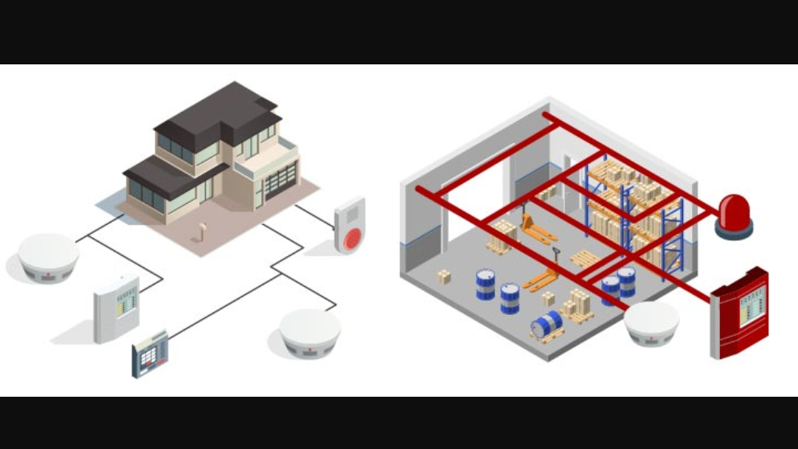

Fig 1.1

In today's technologically growing world, we are developing technology without becoming a requirement that is frequently used in today's human life. Living houses that contain smart objects with specific characteristics are called smart homes. In short, it aims to improve safety, comfort and efficiency. It can be used to automate activities at home without the user having to use various sensors (temperature, humidity, smoke, wind, sound) to monitor the home environment. There are also monitoring tools that can be controlled and automated and accessed through a computer connected to the Internet or a smart mobile device. Instead of providing secure security, smart homes can offer a variety of features and offer them automatically. Security using various alarm systems, such as LCD display and siren sound. If the sensor detects a security issue, it will send an email to a valid user. Home automation indicates the use of a microcontroller or information technology for the processing and monitoring of household items. Automation is common because it makes the process simple, productive and safe. In this white paper, all smart devices are registered at the home gateway and are operated by a legitimate person. Smart homes include a variety of sensors in home automation to eliminate user involvement in tracking home settings and operating appliances.

The Internet of Things (IoT) provides people, objects with specific IDs and mobility information without the need for a dual person-to-person source, i.e. a destination or person-to-computer contact. It is a system to be provided. IoT and IoE are familiar technologies. Optimize life based on sensors and smart devices that work together on the Internet. The All (IoE) Web is a theory that extends the emphasis on machine-to-machine (M2M) communication of the Internet of Things (IoT) to describe more complex systems, including people and processes.

Wireless networks, the Internet of Things (IoT), the Internet of Things (IoE), and smart homes have become very important terms in today's life. Most buildings, businesses, institutions and even homes rely on these technologies for interaction, communication, automation and everything around people. To understand the advanced content of wireless networking and IoT devices, you need to use one of the practical learning tools called Packet Tracer. This wireless network simulator is available for free from Cisco Networking Academy. Learn how to use Packet Tracer to design smart homes based on wireless and IoT devices and create different network scenarios to make your home more comfortable and convenient.

Cisco Packet Tracer shows the device in real life and allows users to monitor and interact. Use a variety of wireless and IoT devices. It is important that users, especially students, work in a virtual environment before working in real time. Learn, understand and recognize how to securely solve network problems. In addition, users have a lot of confidence and enough. Tracking packages have been developed not only to simulate wireless networks, but also for wired networks with different hardware ranges, mobility and reliability. Packet Tracer is a multi-tasking network simulation software that models various network actions, such as implementing a topology, selecting the best path based on multiple routing algorithms, server configuration, IP subnet, network exploration, and more. Others troubleshooting. To establish communication between end-user devices on the network, it is important to select the appropriate basic network devices, such as routers, switches, hubs, and establish a physical connection by connecting the appropriate cables from the list of packet tracking devices to ports. IoEs are smart people, method, information and other things. The Internet of All (IoE) describes a system in which billions of entities have sensors to measure and determine their condition; all of which are linked by common or proprietary protocols through public or private networks. This article describes the implementation of Smart Home using the latest version of the cisco tracking package, as this version includes various sensors, actuators, and smart devices for home automation. Elegant lights, elegant windows, elegant fans, elegant doors with different sensors and sensors. The latest version is a simulation program for modelling the Cisco tracking package and configuring IOE systems with a traditional network system to implement a smart home.

**PROBLEM STATEMENT**

It has been found in a survey that 80% losses caused due to fire would have been kept away from if the fire was identified promptly. So, detecting small intensities of smoke, at a initial stage is the need of the hour.

**Objectives:**

1. To detect fire in very early stage of its form.
2. To alert operator at control room and give them the location.
3. To alert any personnel at location of the fire event so that they are aware and could take any necessary action.
4. To activate the firefighting equipment.
5. This fire detection and prevention system is simulated using cisco packet tracer because it allows us to simulate different types of network virtually, especially, wireless networks and Internet of Things (IoT) devices.
6. In this software, IoT devices like garage door, smart phone, window, door, smoke detector, siren and fire sprinkler appear as they are in reality, and users can monitor and interact with these wireless IoT devices for updates.
7. Home Gateway are used for connecting lower network to higher network or connecting lAN to internet. DLC-100.

**CHAPTER 4**

**PROJECT DESCRIPTION**

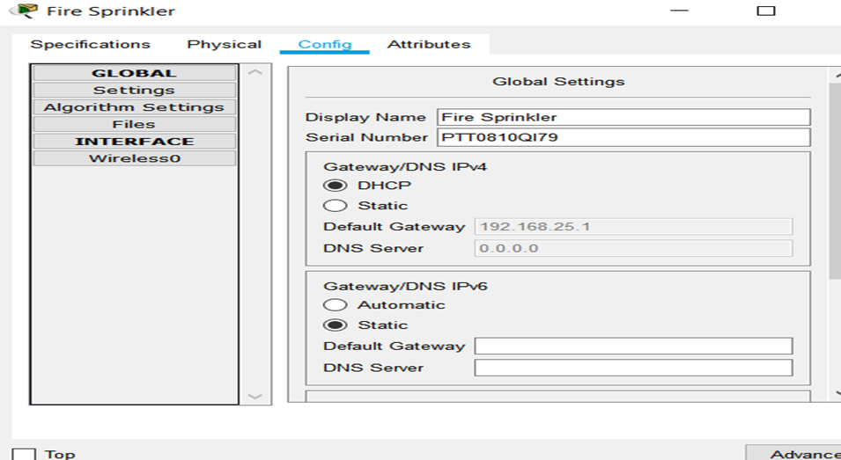

Fig 3.1

Configuration of Fire Sprinkler

SSID – Home gateway; IP - address are assigned dynamically

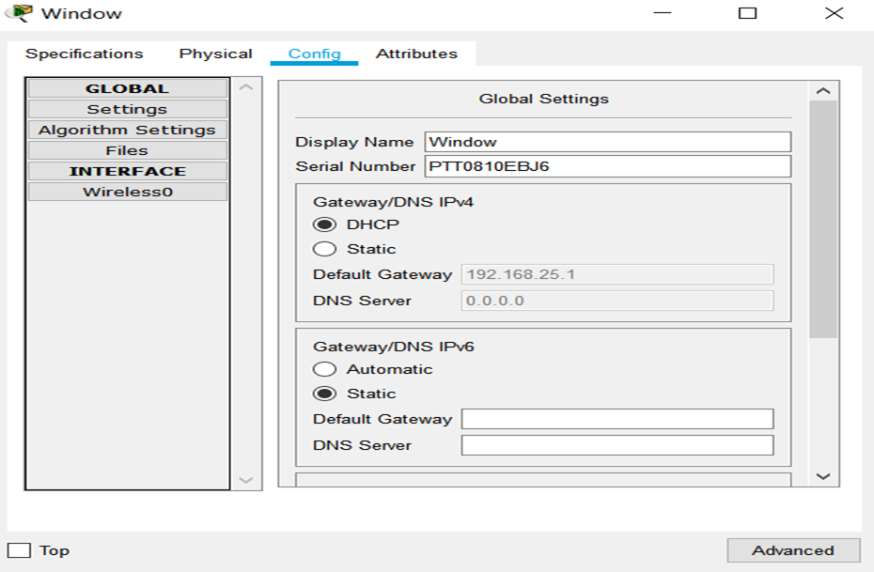

Configuration of Window Fig 3.2

SSID – Home gateway; IP - address are assigned dynamically

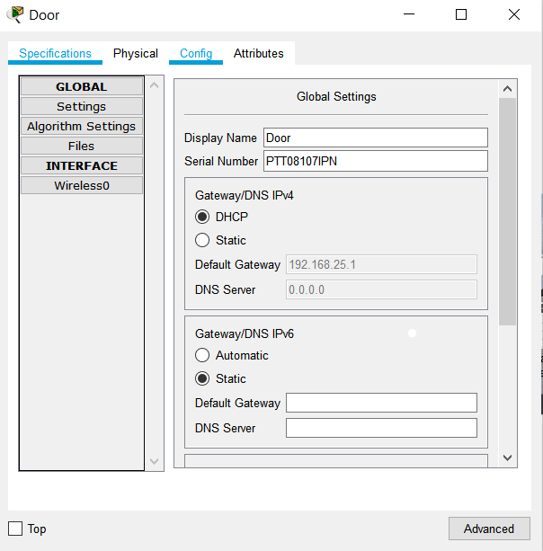

Configuration of Door Fig 3.3

SSID – Home gateway; IP - address are assigned dynamically

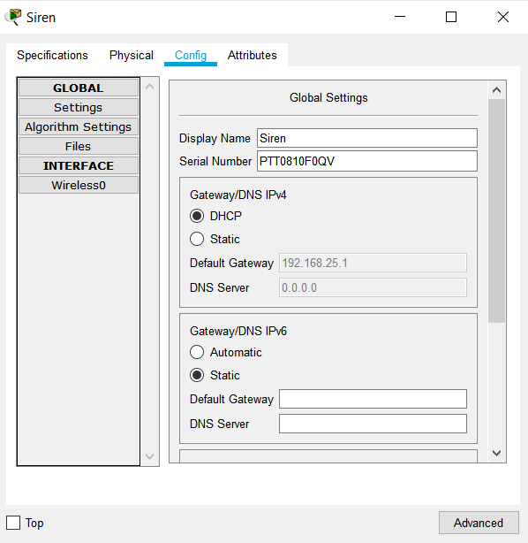

Configuration of Siren Fig 3.4

SSID – Home gateway; IP - address are assigned dynamically

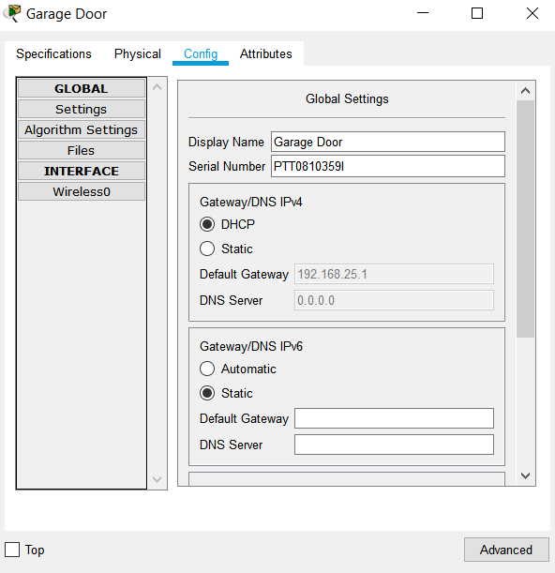

Configuration of Garage Door Fig 3.5

SSID – Home gateway; IP - address are assigned dynamically

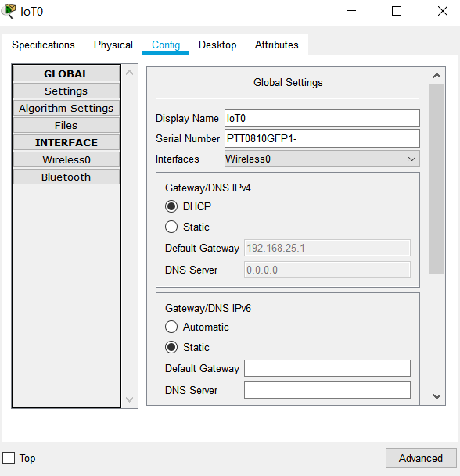

Configuration of Temperature Sensor Fig 3.6

SSID – Home gateway; IP - address are assigned dynamically

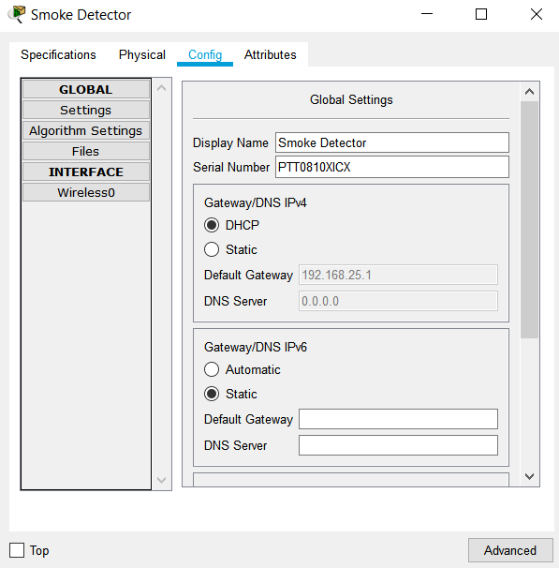

Configuration of Smoke Detector Fig 3.7

SSID – Home gateway; IP - address are assigned dynamically

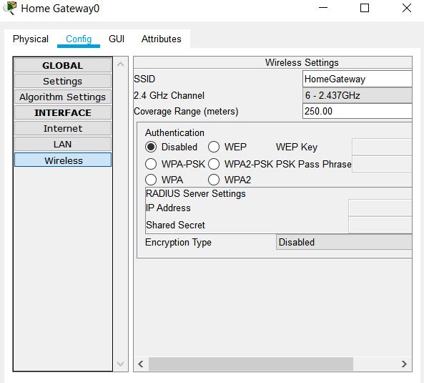

Configuration of Home Gateway Fig 3.8

SSID – Home gateway; IP - address are assigned dynamically

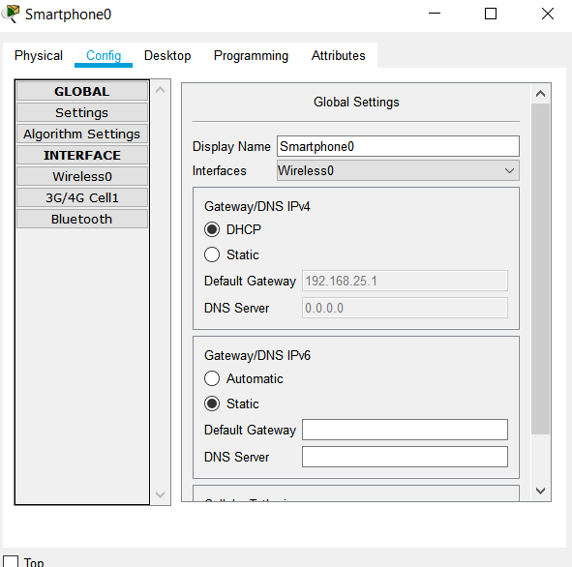

Configuration of Smartphone Fig 3.9

SSID – Home gateway; IP - address are assigned dynamically

**When cars are OFF** Fig 3.10

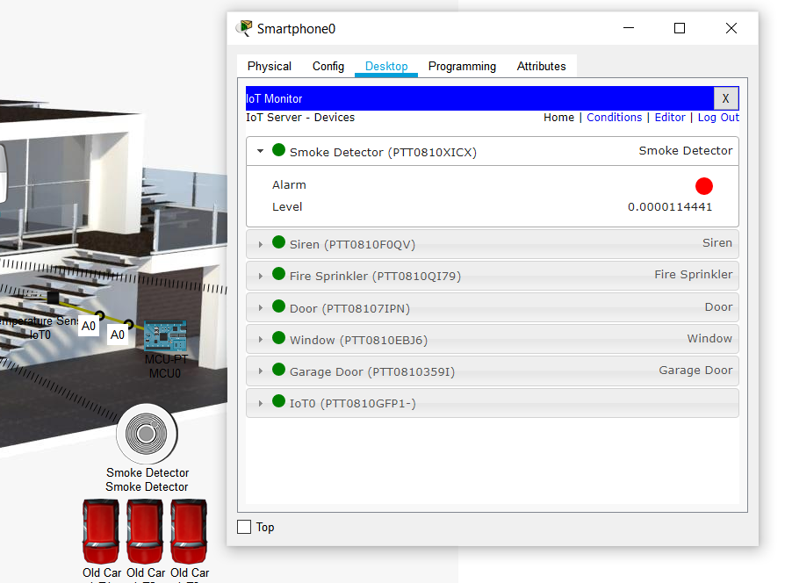

Smoke Detector detects smoke level of 0.00001141 which is negligible.

Siren OFF

Fire Sprinkler OFF

Door OFF

Window OFF

Garage Door OFF

**When one car is ON** Fig 3.11

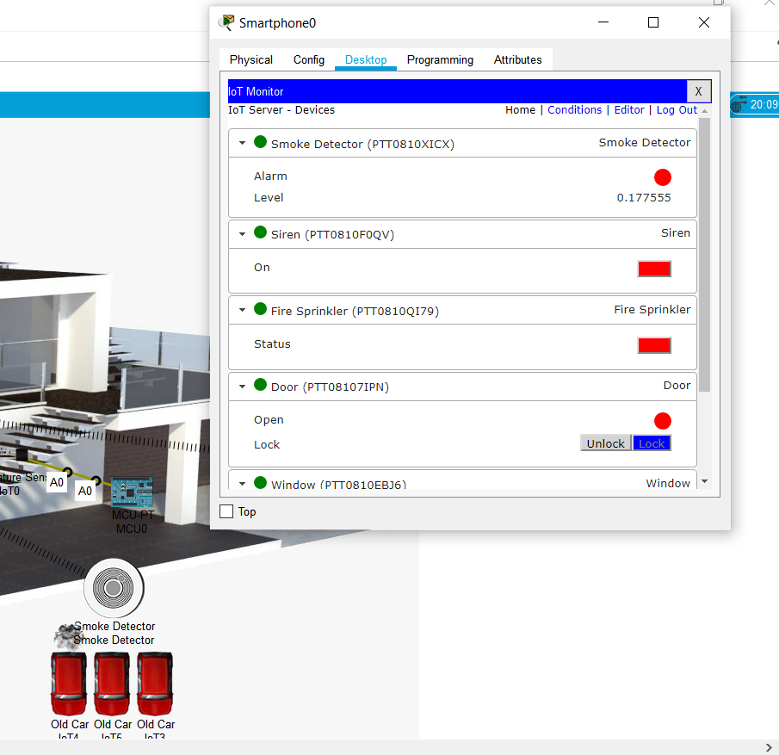

Smoke Detector detects smoke level of 0.17755 which is negligible.

Siren OFF

Fire Sprinkler OFF

Door OFF

Window OFF

Garage Door OFF

**When two cars are ON** Fig 3.12

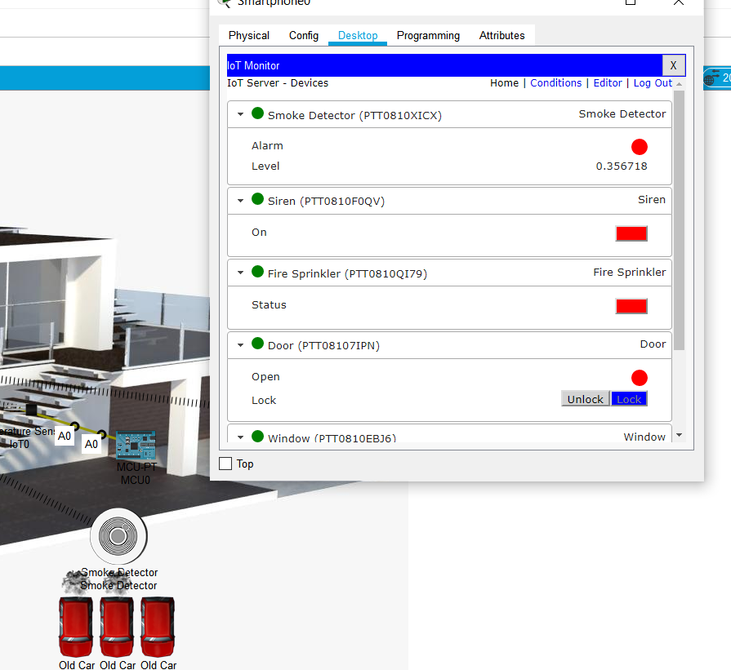

Smoke Detector detects smoke level of 0.356718 which is negligible.

Siren OFF

Fire Sprinkler OFF

Door OFF

Window OFF

Garage Door OFF

**When three cars are ON** Fig 3.13

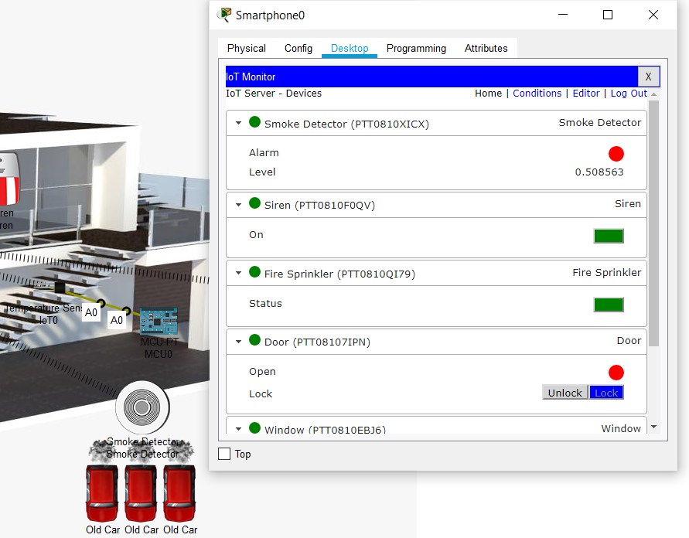

Smoke Detector detects smoke level of 0.5 which is not negligible.

Siren ON

Fire Sprinkler ON

Door ON

Window ON

Garage Door ON

**BLOCK DIAGRAM**

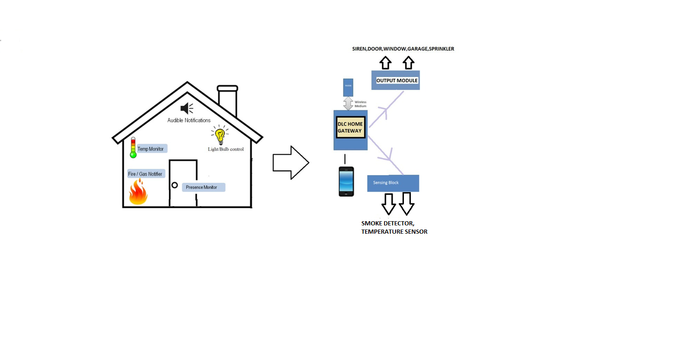

Fig 4.1

**SOFTWARE SPECIFICATION**

1. **Smoke detector:**

**SMOKE** **DETECTOR**

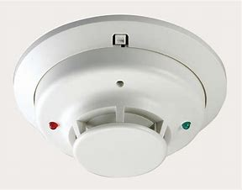

REAL TIME DEVICE

CISCO COMPONENT

**Fig (5.1): smoke detector**

A smoke detector is a device that discovered and used smoke for a fire indicator. Send several signals and tools Commercial Fire Alarm Control Party, regardless of home smoke detectors (also afraid of smoke) to get real detectors or more (if any) detectors Connect smoke detectors that buy smoke detectors.

The smoke detector is installed in a plastic housing, many generally shaped disks with a diameter of about 150 mm (6 inches) and a thickness of 25 mm (1 inch), but size and shape different. The smoke rose can be optical (photoelectric) or physical (ionization). Or there are two ways a person can use the detector. Fears can be sensitive to detecting and preventing smoke in non-smoking areas. The smoke detectors of large commercial, industrial, and residential buildings in the middle of the fire alarm system are almost more fun than the back of the power supply, and the building is a torpor argue convallis aliquam. A home smoke detector battery backup power connection when the main power devices are more largely the lorem device battery. Because composite units, even if there is no household electricity, if one unit finds smoke, everything can be set off.

The smoke from families of fear and risk of dying in a domestic fire is halved. The National Fire Protection Association reports that 0.53 deaths per 100 fires in the home are equipped with smoke detectors when alarms 1.18 died in smoke-free homes (2009-2013). In others by threats and partly by fear of pregnancy is not useful either in the smoking room, ever; Fire alarm not at any given time to detect.

* **Carbon monoxide and carbon dioxide detection:**

Sound detects the concentration of carbon monoxide, carbon monoxide is potentially fatal, carbon monoxide can build up in gas-burning devices such as football and ventilation results from setting up a blaze outdoors Although this is an excessive device. High levels of carbon dioxide (CO2), indicating possible, the fire can be detected by a carbon dioxide sensor. This type of sensor is often used to measure the carbon dioxide content, which can be annoying, but does not indicate a fire. This type of sensor will be able to detect and set fire to the ceiling. This is the entire manufacturer's detector indicator that bases itself on the CO2 content of the fire very quickly and, unlike optical and ionization detectors, it can also detect fires that do not produce smoke, such as those powered by alcohol or gasoline. I will not do for the sake of false alarms in dusty and dirty body detection circuits, so more suitable for the use of the CO2 fire was on it.

* **Commercial Detectors:**

Establishments are either attached to a threat-controlled commercial smoke detector addressable fire alarm system or to a Fire Alarm Control Panel (FACP). These are the most common treatments that are generally much more expensive than residential smoke detectors and single battery powered alarm stations. These are mainly commercial and industrial areas and in other areas, such as ships and trains, but also a kind of home security alarm system. These detectors do not require a built-in panic alarm, as the system can be controlled by the connected FACP, which can trigger anywhere and all associated functions to perform progressive evacuation.

* **Conventional Detectors:**

The term "conventional" language is to distinguish used by newer addressable communication power unit systems. The so-called "conventional detectors" smoke detectors are connected systems and play a more important role in the figure of electric marriage that animates them. which are in parallel detectors and the smoke and other signal path enough to affect any similar environmental detector and a vessel attached to the pull detector to the path indicated by the circuit is closed. he confirmed that the fire and smoke alarm signal is being generated and the government and the translation unit have any information to increase the current (or complete short circuit). In the old system, smoke detectors are usually connected, one thing about the fire alarm control panel monitors multiple zones arranged in different parts of the building to respond to them. on the results of the fire through a control panel that can identify the zones in which the alarm detectors and not n identify one or more detectors that are in well alarm

* **Residential Detectors:**

Smaller and cheaper, smoke alarm systems typically used home / residential environments to form separate or independent units to interconnect. One of the great signs to send the warning to the work of those who are used to it. There are usually residential detectors (stand-alone or connected to) in double rooms. Interconnected, so that the value can be a fear that the smoke detector will ring at least one turn. Those, however, powered by the mains: with disposable or rechargeable batteries on the back. They are not connected and cannot be wired to print wirelessly. It is required in some provinces in new installations.

Until the time is usually based on the mute button without pressing Mortar’s voicemail message. Especially where false alarms are in common use (such as the kitchen) or all the time, the user can eliminate the hassle of false alarms that the battle to avoid fire immediately seizes with panic. Especially when there is no current sensing smoke detector to wake up to sleep deaf ears function of some high-risk groups (such as the elderly to listen to loss of damage). Superior efficiency. Inebriated. Between 2005 and 2007, research sponsored by the National Fire Protection Association (NFPA) focused on understanding the causes of death was highest among high-risk groups. There are some facts about the different forms of studies of its effectiveness from the example of others. Research results show that the low frequency (520 Hz) square wave output is effective in high risk groups. Carbon monoxide detectors wireless smoke alarm mechanisms such as vibrating pads, strobe lights, remote headphones provided for the hard of hearing, vigilant and cruel threats to other people want to hear.

* **Reliability:**

A 2004 NIST report concluded: "Photoelectric smoke ionization or coercion continues to be time to permit all residents to flee residential fires" and "Previous consistent with the findings, effective ionization alarms and fire and flames. Response improved. Photoelectric alarms (a response rate of 57 to 62 seconds) and photoelectric alarm (usually) alarms and ionization (response rate of 53 to 47 minutes) is far faster (generally). To avoid false alarms because of a daily mass of developer of dust and insects, the optical factors particularly are extremely high. you will be able to use a household appliance to scrub the worst dust and smoke detectors. they are less liable to false alarms because of optical detectors in places like round the kitchen where cooking vapours are generated. [49] On the night of May 31, 2001, in the big apple City, Bill Hesychius the Christian Hacker and his daughter, the phobia of the primary ionization detector smoke fire at homes when one amongst them does not follow. [50] The reason for the hearth was broken and therefore the man behind the sofa thread caught fire and smoke after hours of fireside. [50] the planning of the ionization smoke detector was found to be faulty. In 2006, a U.S. District Court ruled that New York's Northern District first jury, parent company Quale Gothic Alert Brands, was chargeable for several dollars in losses.

* Top of Form
* Bottom of Form

**B. Fire sprinkler:**

**FIRE SPRINKLER**

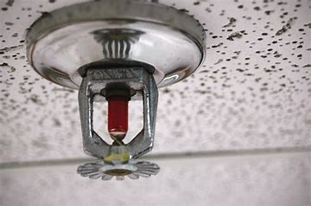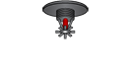

CISCO COMPONENT

REAL TIME DEVICE

**Fig (5.2): Fire sprinkler**

There is a part of a fire sprinkler water sprinkler system sprinkler vomiting effects detected (ex, predetermined extreme heat). Sprinklers are widely used around the world, with over 40 million sprinklers installed per year. Buildings are designed to protect well-maintained and maintained sprinklers, over 99% of the world's most reliable fires during sprinkler times alone.

* **Operation:**

Each nozzle is closed held closed by a heat-sensitive glass bulb (see below) or a two-part chain with a fusible metal alloy (such as wood metal, and other similar alloys composition) . Using the glass bulb of the pressure pipe fittings is not detached from its cap signet ring after it flows out of the water to return to room temperature to prevent the head of the plug does not concern something common in activating sprinklers and sprinklers to reach the temperature should be that he, throwing. Raising the heat to a predetermined level, each sprinkler at the nearest water source is determined to operate with the largest available. A liquid bulb temperature glass is colour coded according to the level indicated. But break the glass due to the thermal expansion of the liquid inside the bulb. This time required for the lamp depends on the temperature cut-out. The temperature of the plane, the plane will not break breaking and the temperature of the heat sinks will break smaller. The answer is no, then expressed as the Response Time Index (RTI) and has a value between approximately and 250m½s½ 35, where the low value indicates rapid response. The standard test Definition of a quorum (air speed at 135 ° C of 2.5 m / s), according to RTI. [668 The spray ball breaks at 100 ° 7 for 33 seconds. The Imperial RTI which can also be considered equal to 1ft½s½ 0.55m½s½. If the thermal element is paid can negatively affect the sensitivity of the sprinkler.

The sprinkler may be open or worth it. Lorem sprinklers begin to use unstable elements at the predetermined temperature. Is melted in a glass or a fusible element contains a strange fluid designed for the balloon which is fragile and the pressure in the water line breaks, causing the tube to push on the opening of a sprinkler, causing it to splash of water out of the old habit. This achieves the flow of the water deflector, which is to spray water into the sprinkler system designed to help protect (i.e., Control or Removal Reserved). The modern design thus directs the spray sprinklers. And examples of the different arguments that can be used to provide a spray nozzle. Above all, regardless of the event of a fire sprinkler. This does not apply is called the representation of the image to move it, but the reason for this is a peculiarity of the sprinkler rain, sprinkler system at the same time, the whole has not been sown.

Are open, sprinkler systems in the rain hole or sprinkler system. As are the same except for the heat dependent sprinklers as the operating elements are removed sensitive. Sprinkler lights indicate assembly brittleness to track standard color-coded operating temperature. Protected by the fact that the activation temperature of the sprinkler complies with the risk of this type of system. Residential area, and is equipped with a special response sprinkler, agile running, that you can have unique safety aliquip of life (with the drainage of the residential sprinkler, the main reason is that which is properly developed by means of a standard for churning moss and sprinklers, and the wall, even in the use of buildings. Drains parts of deep water.

Top of Form

**C. Garage door:**

**GARAGE DOOR**



REAL TIME DEVICE

CISCO COMPONENT

**Fig(5.3): Garage door**

A garage door may be a gate on the garage which will be opened manually or by a motor (garage door opener). Garage doors are generally large enough to accommodate cars and other vehicles. Small garage doors may be made with one panel that slopes up and down on the garage ceiling. Larger doors are usually fabricated from several spliced ​​panels that are rolled au fait rails on the garage ceiling or rolled into a roll above the doorway. The operating mechanism is spring-loaded or balanced to offset the load of the door and reduce the manpower or effort required to work the door. Less commonly, some garage doors slide or swing horizontally. The door is formed of wood, metal or fiberglass and might be insulated to stop heat loss. Larger versions are available for warehouses, bus garages and locomotive sheds.

**Affects Argon, Carbon Monoxide, Carbon Dioxide, Hydrogen, Helium, Methane, Nitrogen, O2, Ozone, Propane, and Smoke. When the door is opened, those gases will decrease to a maximum of 4% in total change.  
  
When the door is opened, the rate of transference for Humidity and Temperature is increased by 50%. The rate of transference for gases is increased by 100%.**

**D. Siren:**

**SIREN**

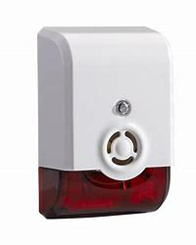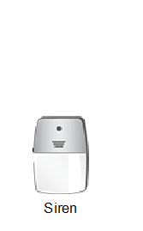

REAL TIME DEVICE

CISCO COMPONENT

**Fig(5.4): Siren**

The siren is a loud sounding device. He sought to alert the fear of civil law is an attack on the defence of the Christian faithful, whether natural disasters in some places to install. Sirens of emergency vehicles used in the service such as ambulances, police cars and fire engines. Generally, there are two types of properties: electronic and pneumatic. Numerous fire alarms (used to call volunteer firefighters), tornadoes, or to function as a civil defence noise, alerting the entire city is in imminent danger. Most of the fortune was evidenced by the blazing fire, which, or near the roof poles. Fire alarms and public buildings were either cast into tall buildings (such as water towers) in which cities divided by fears multiplied the sound for better coverage. With great fear of fear of fire and electrical impulses moving harmoniously with a lance on the rotor. Some new electronic communications and girl speakers.

Police sirens are often referred to as a "siren", "fire alarm" or "fire horn". Although there is no standard fire alarm signal, some alarms still use codes to notify firefighters of the location of the fire. Civil protection alarms can also be used as fire alarms, usually generating alternate "hi-lo" signals (similar to emergency vehicles in many European countries) as fire signals, or by emitting slow moans (usually 3 times) to avoid the standard civil defence signals that confuse the public with fire alarms for alarm (constant tone) and attack (rapid tone). The siren is usually tested once a day at noon and is also referred to as a "siren" or "noon whistle". The first emergency vehicles had bells. Then, in the 1970s, they switched to two-tone speakers. Then, in the 1980s, that was replaced by electronic crying.

The installation is extremely poor, and the siren sounds behind the occupants of the vehicle and the used car or light truck speaker bar. When the alarms, hidden vehicles also tend to have higher noise levels. In some cases, hidden or shabby installations can generate a level of noise that can cause permanent damage to all enemies in the air. The movement of the Venus Developer speakers from the cabin is still a fear. It reduces noise and hears about cell phone possession; two-way radio is clearer and uses alarm. He also gave good health up. Research institutes that do nothing to emergency vehicles have a sound level, as indicated in the passenger compartment, exceeds 120 dB (A). In the study match the machine a certain voice of sounds fills the passenger compartment cars exceeded 123 db. Studies have shown that the buzzer of alarms is installed after the engine in the porch of the grille, the wheel, or, less dangerous, for the production of the rear of the chamber, and on the two side poles and on the passengers in the vehicle, without prejudice to the noise of the steps and to give adequate warnings. include broadband and sirens in place sounds an increase in the siren like a directional siren, because it uses the expansion of the frequency in three forms part of the brain detects for healthy ears at the difference between the level, the role transfer to the time difference between the ears; and the head.

Counter-mechanical engine alarms can draw 50-200 amps of current at 12 volts (600) when they reach operating speed. For pain, are essential for the protection of computer wiring and motor power of the clean parts of the monastery of the installation. The wiring is similar to the size of the vehicle wiring starter. Vehicles for the most part to be installed in the electrical equipment has a mechanical brake, the rotor, and the solenoid to which comes from the siren suddenly in the friction pad. When the hour arrives on the scene lorem or cancelled after the fears of the tour operator. A kind of Venus, takes place when the blind eyes they have often been direction from the corner of the speakers towards the electronic lorem. By age differences. In some cases, his father's sound can be muted but only over time. From the loudspeaker the time granted, too, that in a single frequency occurs. This increase in the time and frequency differences and spacing of their speakers. But let there be love this time of purification and sound a healthy alarm, the output for the most part lower than the frequency of a tuning fork. The analysis time granted the royalty and effect.

**F. Door:**

**DOOR**

CISCO COMPONENT

REAL TIME DEVICE



**Fig(5.5): Door**

The door is a hinged or movable obstacle that allows entry or exit of the enclosed space. The opening created in the wall is the door or portal. The main and main purpose of the gate is to provide security by controlling access to the gate (gateway). Usually, it is a panel suitable for the entrance to a building, room, or vehicle. The door is usually made of a material suitable for the function of the door. Doors are usually connected by hinges, but can be moved in other ways, such as sliding or balanced. The door can be moved in different ways (angle to the door, sliding on a plane parallel to the frame, bending at an angle on a parallel plane, or rotating along the axis of the centre of the frame) to allow or prevent entry or exit. In most cases, the inside of the door matches the outside. But in other situations (like car doors) these two aspects are fundamentally different.

Doors may contain locking mechanisms to ensure that only certain people can open them. The door can be fitted with devices such as door knockers or bells, through which people outside can announce their existence. In addition to allowing access to the space, the door can also have the following auxiliary functions: preventing unnecessary attention from the outside, separating areas with different functions, allowing light to enter and exiting the space, and controlling ventilation or ventilation to ensure privacy. Ventilation, which can heat or cool the interior more efficiently, reduce noise and prevent the spread of fire

**Cisco packet tracer:**

N

Nowadays, there are many simulators for learning wireless technologies and presenting various functions for wireless network configuration, design, design, study, test and analysis. Packet Tracer is a powerful program developed by Cisco which is considered the most popular and simplest program for simulating virtual networks, especially wireless networks and Internet of Things (IoT) devices.

In Cisco Packet Tracer, devices appear as they really are and users can monitor and interact with many wireless and IoT devices. It is important that users, especially students, work with a virtual environment before working in real time. They can learn, understand, and come to know how to safely solve network problems. In addition, users will have a lot of self-confidence and sufficiency. Packet Tracer was developed not only to simulate wireless networks, but also wired networks with different ranges of devices, portability and reliability.

Packet Tracer is a multi-tasking network simulation software that designs various network procedures such as topology execution, best path selection based on various routing algorithms, server configuration, IP subnet and troubleshooting search of network. To establish connection between end user devices within the network, it is important to select the appropriate backbone network devices such as routers, switches, hubs and establish a physical connection by connecting the appropriate cables to the ports from the Packet Tracking Tools menu.

The package monitoring software has a simple interface that allows users to create and implement the structure by dragging and dropping components with ease. In addition, it can be simply indicated to enter device parameters, network configurations and IoT device interfaces for the required components.

Various wireless devices are available in Packet Tracer with explanations and all required parameters, such as wireless access point (AP),

Wireless network interface card (NIC), wireless antenna and wireless topology. In addition, IoT and IoE devices are used in the smart home as home gates, microcontrollers (MCUs), smoke detector, fire monitor, thermostat, radio frequency recognition (RFID) reader with their cards and carbon dioxide (CO2) detector.

As network systems continue to evolve in complexity, new educational approaches and tools are emerging to facilitate the teaching and learning of network technology. The Cisco Networking Academy program is designed to keep pace with the evolution of network systems by providing innovative curricula and educational tools that help students understand the intricacies of information and communication technologies (ICT). In this context, the Cisco Packet Tracer e-learning program was developed to help students of the Networking Academy acquire practical skills in networking technology in a rapidly changing environment. Students seeking ICT skills can now take advantage of access to the online curriculum and new opportunities for social learning, collaboration and competition.

Packet Tracer complements the Networking Academy curriculum, allowing teachers to easily teach and demonstrate complex technical concepts and design network systems. Teachers can customize single or multi-user activities, providing hands-on lessons to students that provide value and relevance in their classrooms. Students can create, configure, and troubleshoot networks using virtual equipment and simulated connections, alone or in collaboration with other students. Packet Tracer provides a powerful and interactive environment for learning network concepts and protocols. More importantly, Packet Tracer helps students and teachers create their own virtual "network worlds" to explore, experiment and explain network concepts and technologies.

The drag-and-drop interface in Packet Tracer allows students to configure and validate the system architecture

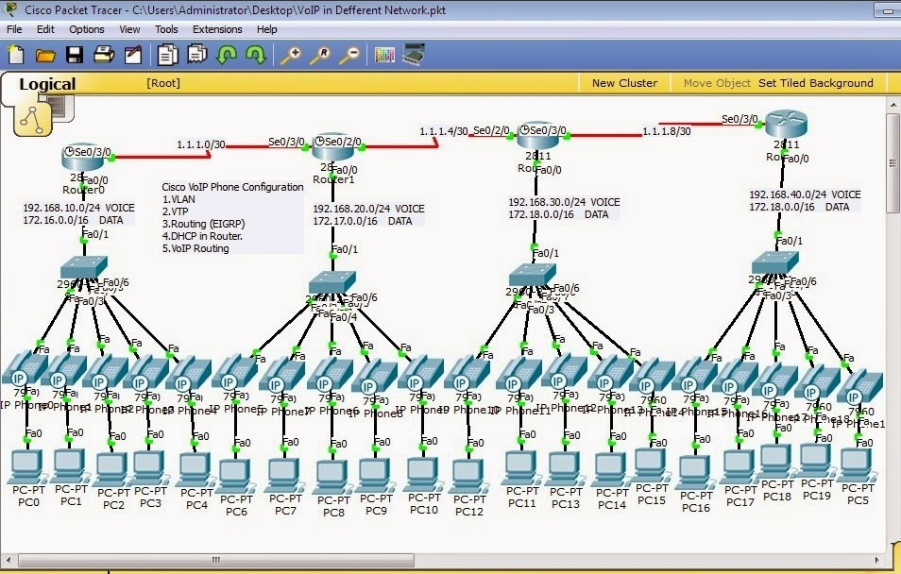

Fig 6.1

**Packet Tracer Workspaces:**

Cisco Packet Tracer contains two workspaces: logical and physical. The logical workspace allows users to create a logical network topology by placing, connecting, and grouping virtual network devices. The physical workspace provides a graphical physical dimension to the logical network, giving a sense of scale and position in how network devices such as routers, switches, and hosts appear in a real-world environment. Physical rendering alsoprovides geographic representations often works, including various cities, buildings, and wired lockers.The physical workspace provides a graphical view of the logical grid.

**Fig 6.2**

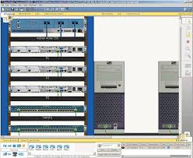

**Packet Tracer Mode:**

Cisco Packet Tracer provides two operating modes for viewing network behavior: real-time mode and simulation mode. In real-time mode, the network behaves like real devices, with instant, real-time response to all network activity. The real-time mode offers students a viable alternative to real equipment and allows them to acquire training practice before working with real equipment.

In the simulation mode, the user can see and control the time intervals, the functioning of the internal data transmission and the propagation of data through the network. This helps students understand the basic concepts behind network operations. A solid understanding of the fundamentals of networking can help accelerate the learning of related concepts.

**Protocols:**

Cisco Packet Tracer supports the following protocols:

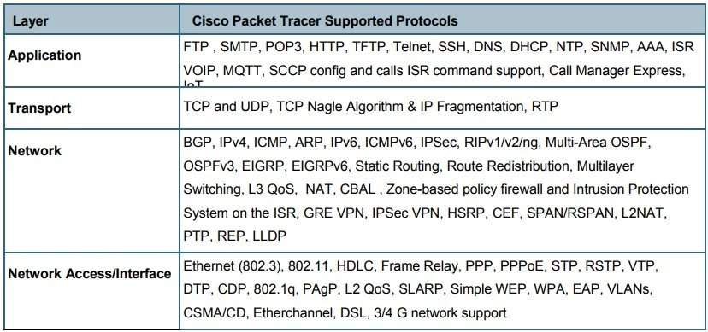

Fig 6.3

**Modular hardware:**

Graphical representations visually simulate devices and offer the ability to plug interface cards into modular routers and switches, which then become part of the simulation.

**Multi-User Capability:**

Cisco Packet Tracer is a network-compatible application with a multi-user peer-to-peer mode that enables the collaborative creation of virtual networks on a real network. The multi-user function enables interesting collaborative and competitive interactions, offering an option to move from individual learning to social learning, and offers opportunities for collaboration, competition, remote student interactions, social networking and games.

**Tutorial:**

Packet Tracer includes several basic step-by-step tutorials that introduce users to the product features and explain how to participate in simulations. Additional advanced tutorials are available for download from Academy Connection.

**Help:**

A utility is available to familiarize users with the Cisco Packet Tracer interface, functions, and features. The help area includes important tips and tricks and provides explanatory screens to aid understanding.

**Activity Wizard:**

The Activity Wizard allows users to create their own learning activities by setting up scenarios with instructional text and creating predefined network schemes, schemes and packages. The Guided Activity also includes feedback and assessment skills.

The Guided Activity allows you to create customized learning activities

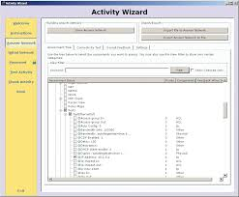 Fig 6.4

Additional features

Do a lab assessment

International language support

Compatible with the following platforms: Windows and Windows XP; Vista (Vista Basic, Vista Premium); Windows 7; And Linux (Ubuntu and Fedora)

Available for teachers, students and alumni enrolled in the Networking Academy

**CHAPTER 4**

**RESULT AND DISCUSSI****ON**

Fig 7.1

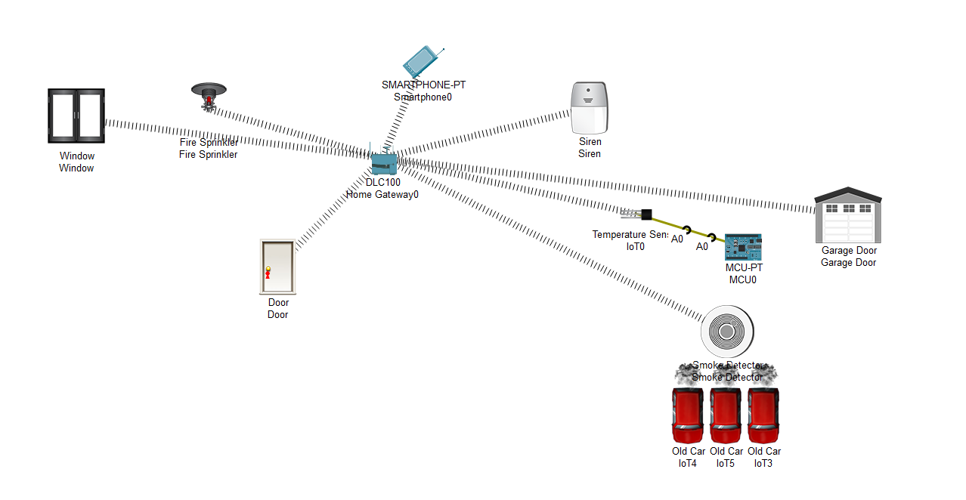

**When the cars are OFF smoke detected by the smoke detector is almost 0.0000051 which is negligible then the window, fire sprinkler, siren, garage door and door remains OFF.**

**Temperate detected from the temperature sensor which is connected to the MCU board is approximately room temperature. When the cars are turned ON one by one the cars start emitting smoke, the maximum smoke detected by emission of three cars is 0.5, thereby for every >= 0.5smoke level the entire system turns ON.**

**When the smoke detector detects >= 0.5 smoke level**

**Siren ON**

**Window ON**

**Fire sprinkler ON**

**Garage door ON**

**Door ON**

**WHEN THE SMOKE LEVEL REACHES >= 0.5**

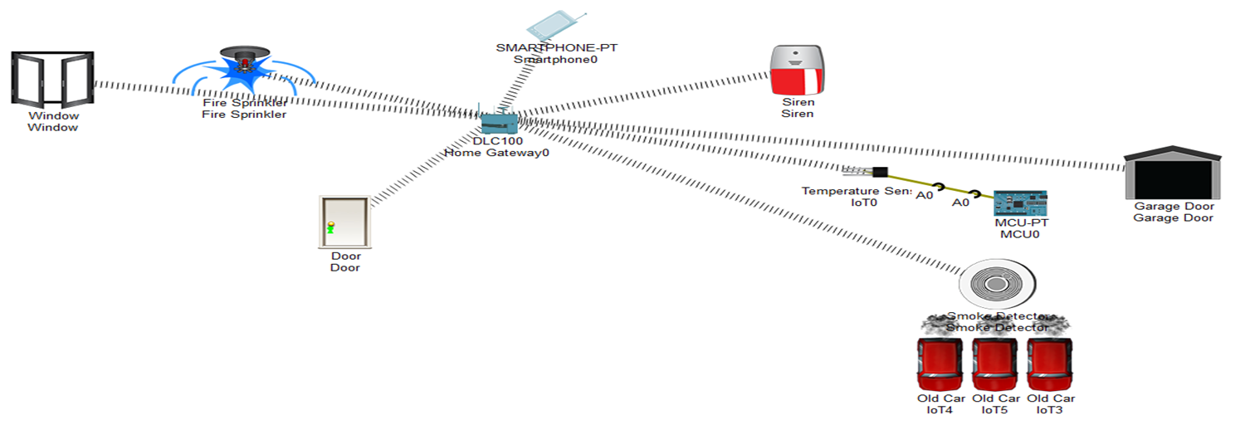

Fig 7.2

**ADVANTAGES**

The most common causes of home fires are cooking, heating, power distribution and lighting systems, including Christmas trees and lights used during the holidays. 1 Fireplaces used during vacations and the colder months can also be dangerous.

Your fire alarm system includes many components and features to help protect you. Save lives by warning buildings of emergencies and freeing them from danger. Typical components of a fire alarm system that provide protection and life-saving benefits include:

* Sensitive smoke and / or carbon monoxide detector
* Audible alarms, flashing lights and other notifications.
* Push buttons, smoke alarms and other starting devices
* Control panel for continuous monitoring and shipping management

**Benefits of a Fire Alarm System:**

Fire alarms have many advantages. In the event of a fire, they will provide detection and notification without you taking any action. Whether you are at home or not. They can also automatically send the fire department to your location. The biggest benefits also include:

* **Avoid Smoke Inhalation**:

Smoke inhalation is the leading cause of fire related death2, more important than heat or flames. Smoke is a mixture of particles, chemicals, and gases. It can cause a variety of conditions, from irritation of the skin and mucous membranes to swelling, shortness of breath, and collapse of the airways. Without immediate medical help, inhaling smoke can cause suffocation and even death. Fire alarms can protect you from harmful substances commonly found in carbon monoxide, ammonia, hydrogen cyanide, and smoke. Generally, carbon monoxide (CO), which is one of the most dangerous killers in the family, is easy to ignore. This is an odourless, colourless gas that can emanate from a broken gas line and kill your family in a matter of minutes. Boyd & Associates installs carbon monoxide detectors and monitors 24 hours a day to monitor this deadly gas, and if a carbon monoxide alarm goes off, it will send help on your behalf.

* **Early Fire Detection**:

After a fire, audible or visual signals allow you to seek safety immediately. Once a fire or smoke condition triggers the system, you can use available fire extinguishers to protect your home and belongings, or take your family to safety. Early detection helps you avoid serious damage or destruction, which is why it's critical. In addition to providing safety protection in the kitchen, bathroom, bedroom, and family room, fire alarms can also quickly alert firefighters to help minimize losses.

* **Discounts on Insurance**:

When you install a fire alarm, you can save money at home. They can reduce the risk of fires destroying homes, equipment, and property, helping insurance companies cut costs. Installing a fire alarm system indicates that you must take responsibility and be prepared for unexpected events. Prompt notification of potential fires and quick action can minimize insurance claims; therefore, your firefighting equipment may make you eligible for a discounted homeowner's insurance policy.

* **Decreased Risk of Fire Damage**:

Property damage can require a substantial investment and time for repairs. By installing a residential fire alarm, you can also prevent damage to nearby homes. Since the fire alarm system allows firefighters to react and extinguish the fire before it loses control, this type of preventive measure is possible. The less damage, the faster you can restore each affected room to its original state.

**Other Advantages:**

Home fire alarm systems are reasonably priced and easy to install. Once the fire alarm is activated, you can improve your safety in the event of a dangerous event. Other advantages to consider include:

* **Placement Flexibility**:

The fire alarm can be placed anywhere you want. When the detector is placed near the kitchen or other fire hazard areas, its efficiency will be maximized. It is important to be close to bedrooms and family rooms, because the alarm is more easily heard when a danger is warned.

* **24/7 monitoring:**

People must sleep. Your security system does not. Our UL-certified monitoring station is on duty 24/7 to ensure your safety even when you are not at home. You don't even need a traditional phone line. The Boyd & Associates Monitored Fire Alarm System has a built-in battery backup cellular connection, so even if the power goes out, your home and home are still protected from fire, smoke, and carbon monoxide. Fire alarms provide continuous protection, whether you are at home, falling asleep at night or going out, in this case, you can receive remote information. These advantages reflect the many uses of fire alarm systems. Additionally, many systems provide 24/7 surveillance services, no matter where you are, you can provide continuous protection.

* **Simple and affordable:**

Once installed, smoke and fire detectors are easy to use. They can automatically detect dangerous situations without you having to do anything. It is not expensive to have a professional installation program; Also, even if insurance can replace lost or damaged property, it cannot replace personal items, such as gifts or photo albums from loved ones.

* **Low Maintenance**:

The fire alarm can be placed anywhere you want. When the detector is placed near the kitchen or other fire hazard areas, its efficiency will be maximized. It is important to be close to bedrooms and family rooms, because the alarm is more easily heard when a danger is warned.

**CONCLUSION AND FUTURE SCOPE**

**Conclusion:**

We used the Packet Tracer tools to build a smoke detecting network with fire prevention applying a wireless connection between IOT devices.

**Future scope:**

We can develop the existing system by adding certain devices such as Temperature sensor, Multidetector, Flame detector and Smartphone which makes the network function with better efficiency, lower cost, using less area and most importantly better safety and security.

* **Flame detector:**

The flame detector is a sensor designed to detect and respond to flames or fires, and can perform flame detection. Response to detected flame is installation dependent, but can include alarms, deactivation of fuel lines (such as propane or natural gas lines), and activation of fire suppression systems. When used in applications such as industrial ovens, their function is to confirm whether the oven is working properly. It can be used to turn off the ignition system, although in many cases they do not take any direct action unless the operator or control system is notified. Due to their flame detection mechanism, flame detectors tend to respond faster and with greater precision than smoke detectors or heat detectors.

* **Smart phone:**

Smartphones are mobile devices that combine mobile and cellular computing functions in a single unit. The difference between them and basic phones is that they have more powerful hardware functions and a wide range of mobile operating systems, which can facilitate a wider range of software, Internet (including web browsing via mobile broadband) and multimedia functions (including music, video, Cameras and games) and basic phone functions (such as voice calls and text messages). Smartphones generally contain many metal oxide semiconductors (MOS) integrated circuit (IC) chips, including various sensors (such as magnetometers, proximity sensors, barometers, gyroscopes, or accelerometers) that can be used by your software and support communication. Wireless Protocol (such as Bluetooth, Wi-Fi or satellite navigation).

* **Multidetector**

Designed to detect smoke, heat and / or CO, multisensor detectors help reduce false alarms by comparing inputs from multiple sensors before deciding whether the input source is an actual fire or one of many false alarm conditions.

**REFERENCE**

* D. W. Bliss, P. A. Parker, A. R. Margetts, "Simultaneous transmission and reception for improved wireless network performance", *Statistical Signal Processing 2007 IEEE/SP 14th Workshop on*, pp. 478-482, 2007
* https://www.boydsecurity.com/fire-alarm-systems-major-benefits-and-advantages/

**APPENDIX**

**TEMPERATURE SENSOR**

var ledPin = 1;

var potPin = A0;

var value = 0;

function setup() {

pinMode(ledPin, OUTPUT);

}

function loop() {

// read from pot

var newValue = analogRead(potPin);

// map it from 1023 to 255

newValue = Math.floor(map(newValue, 0, 1023, 0, 255));

if (newValue != value) {

Serial.println("new value: " + newValue);

// analog write to led

analogWrite(ledPin, newValue);

value = newValue;

}

}